CYCLE 1:

Q) Write a syntax and usage the directory management commands with all options.
1)
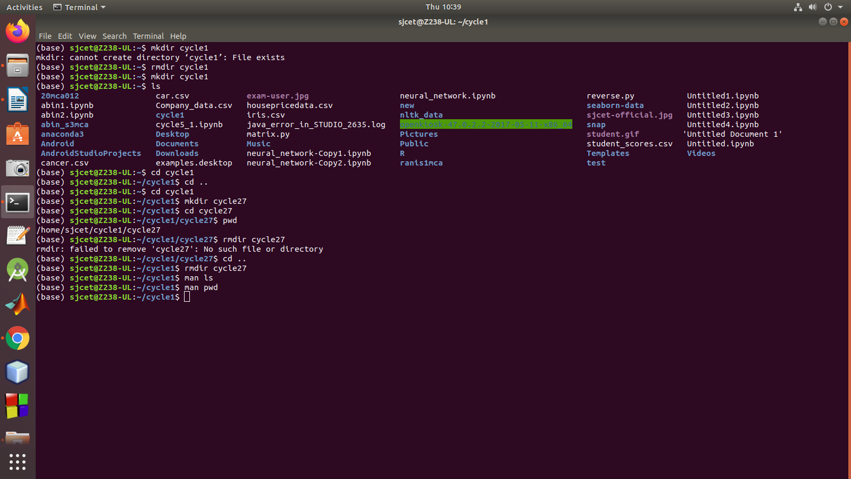

2)

